### Password Expiration

Passwords will expire according to a time limit set by the system administrator (this configuration must be performed in the database by a member of the HIE Advantage team).

Once logged in, users whose password is about to expire will see a warning window. Users must choose to change their password now, or wait until later. Expired passwords must be changed.

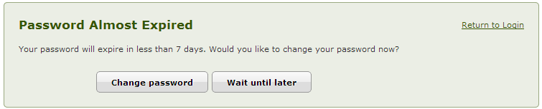

Note: By default, this warning will not be shown to any user with the Administrator role. The warning can be turned on by a system administrator.